Virtual Lab 1 – Plane Waves

# Youssef Samwel

# [yo800238@ucf.edu](mailto:yo800238@ucf.edu)

# EEL4436C Microwave Engineering

Section 0012

# Due Date 9/24/2023

# **Laboratory Description**

# The students were tasked to simulate the propagation of a plane wave through a finite volume using HFSS software. In addition to the simulation, the students were tasked to plot the electric and magnetic field and perform analysis on the simulation.

# **2.0 Computer Simulation (HFSS)**

The primary objective of this laboratory is to familiarize students with the principles of waveguides through hands-on computer simulations conducted with the aid of Ansys HFSS software. Throughout this lab, students were tasked with the construction of two distinct waveguides, aiming to grasp the dynamic behavior of the reflection coefficient, denoted as $Γ$, across varying frequencies. Additionally, they were encouraged to meticulously analyze the scattering parameters, often referred to as S-parameters, to deepen their comprehension of waveguide behavior and transmission characteristics.

The initial waveguide, as specified in the lab manual, took the form of a rectangular enclosure with dimensions measuring $20x100x10 {mm}^{3}$. It was configured with PEC (Perfect Electric Conductor) boundary conditions for the two sidewalls along the x-axis, and PMC (Perfect Magnetic Conductor) boundary conditions for the two sidewalls along the z-axis. The rationale behind this material property assignment was to guarantee that electromagnetic waves propagating within the waveguide remained confined within its confines. This was achieved by leveraging the perfect reflection characteristics of PEC and PMC, which ensured that the electric and magnetic field components of the electromagnetic field experienced complete reflection, thereby preventing radiation from escaping the waveguide.

To measure the electromagnetic field propagation inside this waveguide, we must place a non-model surface to view the EM field. The reason we use a non-model surface is to avoid interfering with existing EM field inside the waveguide. The measuring surface is at the center of the object volume.

HFSS Waveguide Volume and Measurement Surface

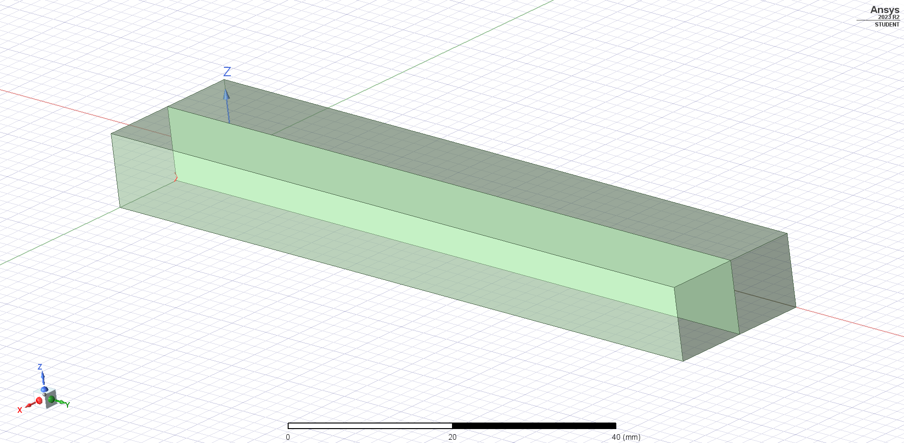

A pivotal stage in the simulation process involves the triangulation of the complex object specified by the user. Within Ansys HFSS, objects are internally represented using meshes comprised of tetrahedral elements. The primary objective of employing a mesh-based simulation approach is to facilitate the representation of intricate objects that cannot be easily defined by mathematical functions alone.

An inherent consequence of this method is that the basic shapes utilized to construct the object may sometimes be too coarse, leading to abrupt changes in the electromagnetic (EM) field. To address this issue, HFSS conducts multiple iterations of the simulation. In each iteration, the software subdivides the mesh into smaller segments, thereby enhancing the accuracy of the EM field approximation. This iterative process continues until the computed error margin aligns with the user-defined limits.

The subsequent sections present the meshes generated for this particular waveguide, illustrating the progression of mesh refinement in pursuit of more precise simulation results.

Mesh of volume

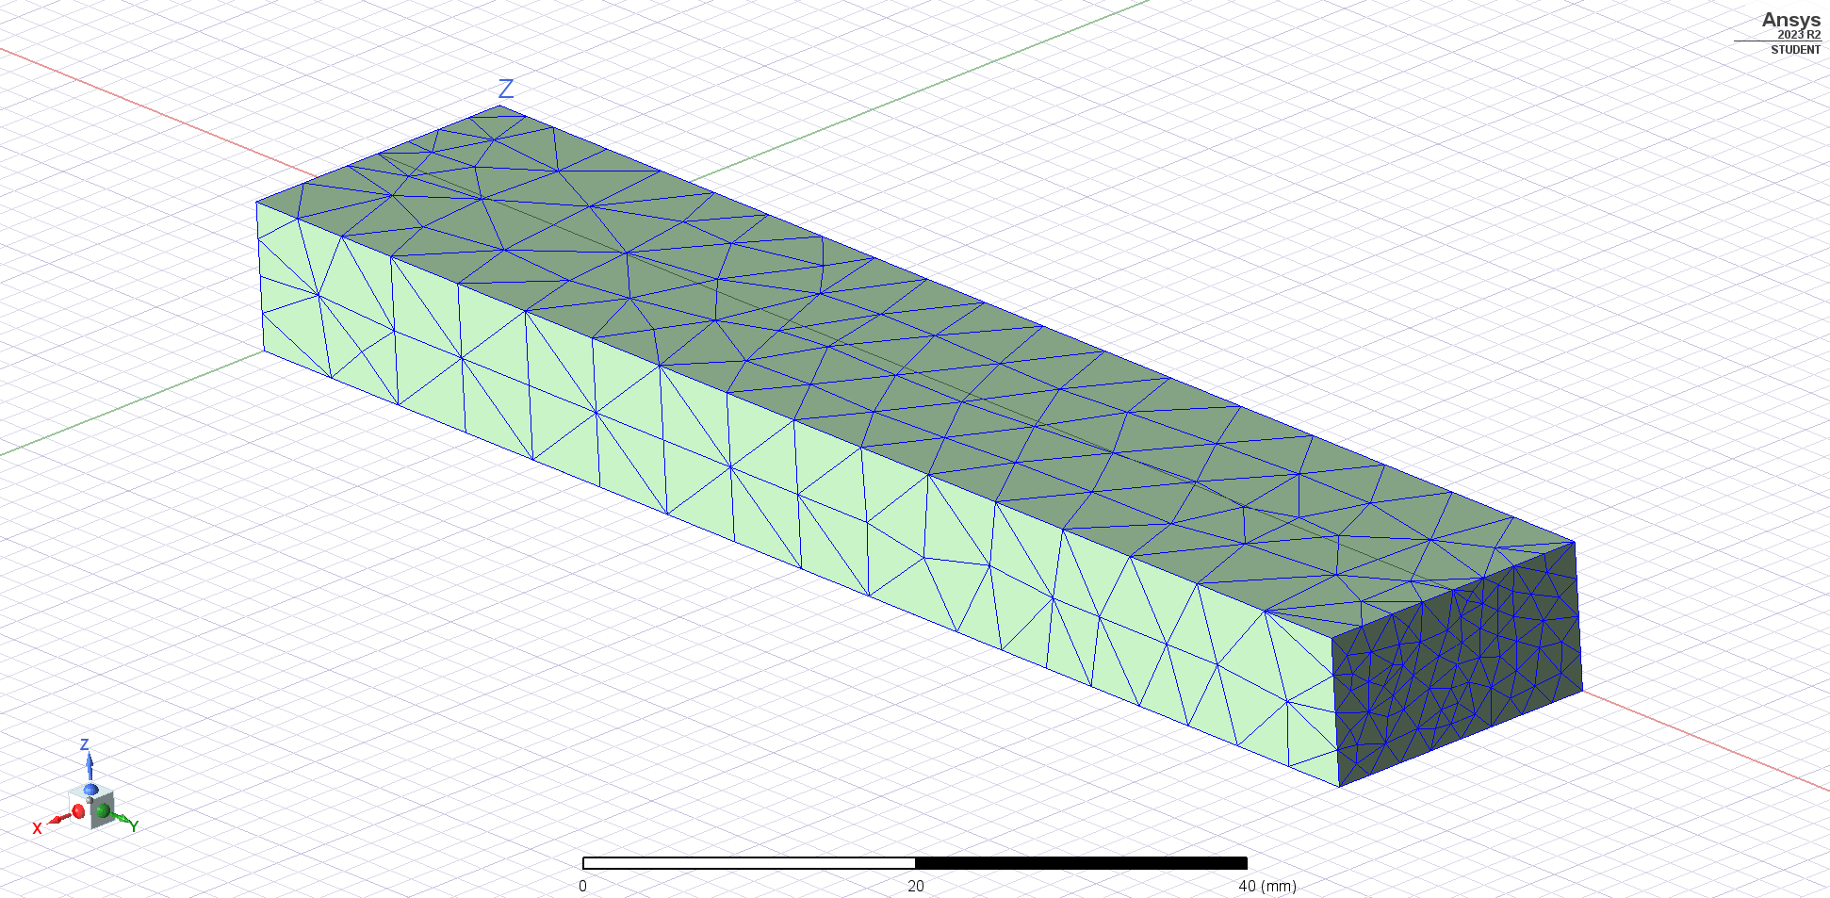*Mesh of surface*

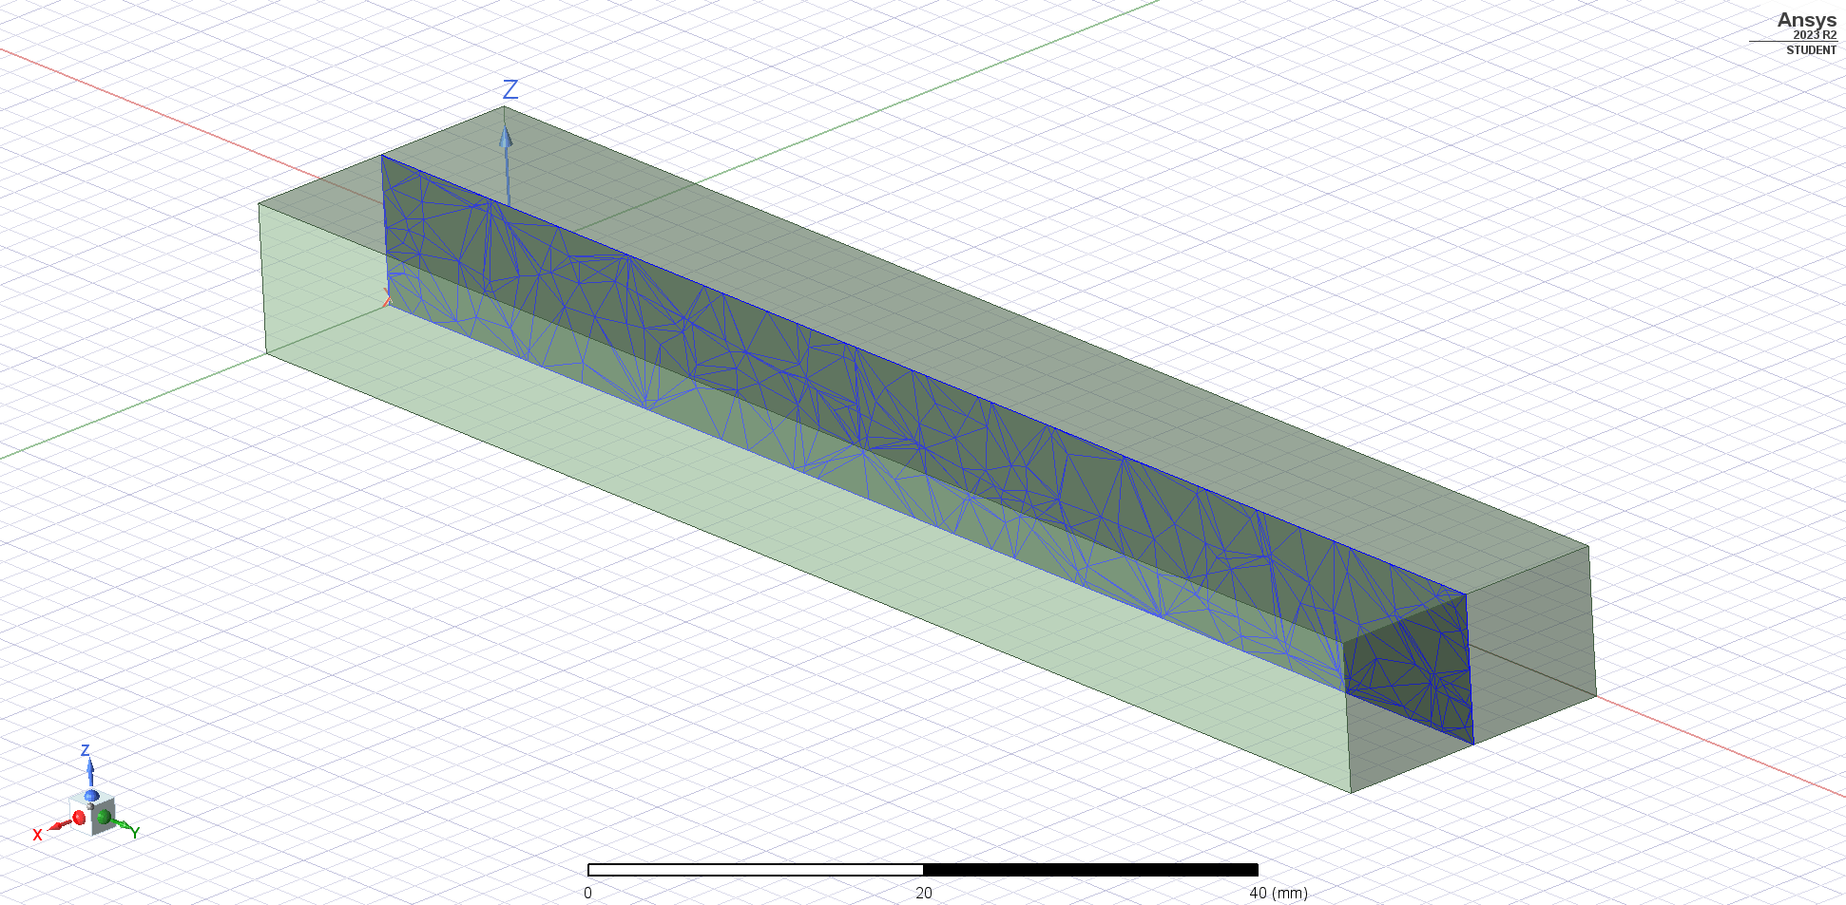

The following is our simulation parameters:

* Frequency = 11 GHz
* Maximum Number of Passes = 3
* Maximum Delta S = 0.02

The concluding step for the first waveguide involves the computation of the EM field within the waveguide's interior. The reflection coefficient (Γ) is expected to be zero, affirming that there is no reflection occurring within the waveguide. This observation is consistent with the behavior expected from a waveguide characterized by a homogeneous material composition throughout its length.

Electric Field

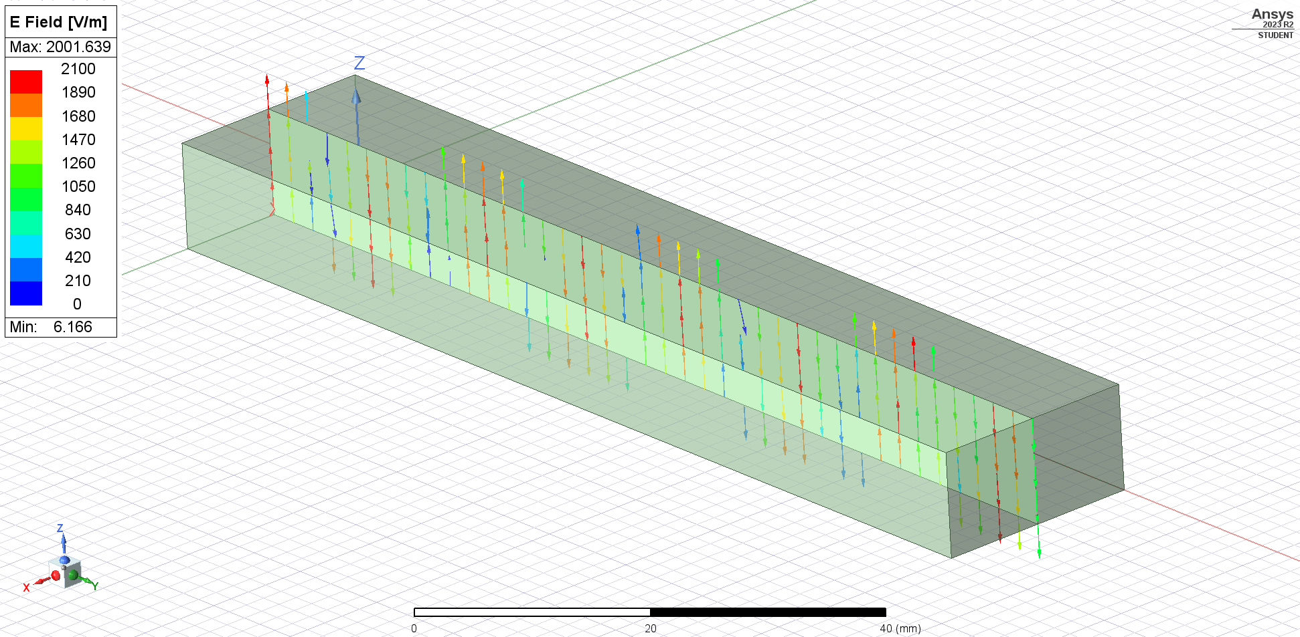

Magnetic Field

We simulated a frequency of 4 GHz and performed a frequency sweep from 1GHz to 11GHz. We computed the 11GHz wavelength to be,

$$u_{p}=\frac{1}{\sqrt{μ_{0}ε_{0}}}≈3*{10}^{8} m/s$$

$$u_{p}=λf→ λ=\frac{u_{p}}{f}≈\frac{3*{10}^{8}}{11*{10}^{9}}≈2.72 cm$$

This can be confirmed by HFSS measurement,

Measurement of Repetition in Waveguide

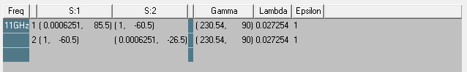

The second waveguide closely resembles the first waveguide, but with the notable addition of another region within the waveguide. This internal region measures $20x50x10 {mm}^{3}$ and possesses distinct material properties, with $ε_{r}=9$ and $μ_{r}=1$. The overarching goal of this modified waveguide is to investigate and gain insights into wave reflection phenomena that arise due to a change in the material properties within the waveguide. Below, we present a visual representation of the waveguide to facilitate a clearer understanding.

HFSS Waveguide with two materials.

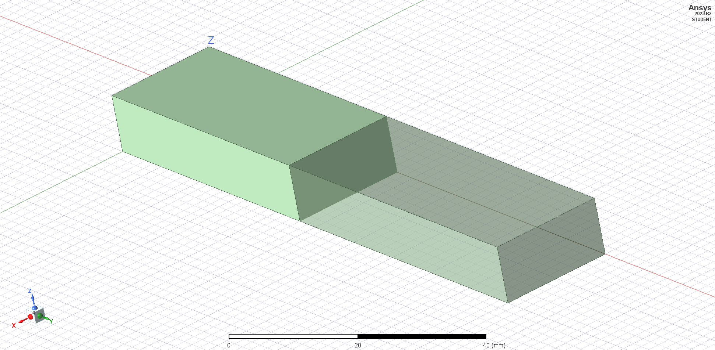

The following is our simulation parameters:

* Frequency = 4 GHz
* Maximum Number of Passes = 5
* Maximum Delta S = 4e-04
* Frequency Sweep Start = 1GHz
* Frequency Sweep End = 5 GHz
* Frequency Sweep Point Count = 4000

The following is the triangulation of the waveguide objects.

Triangulation of custom material volume

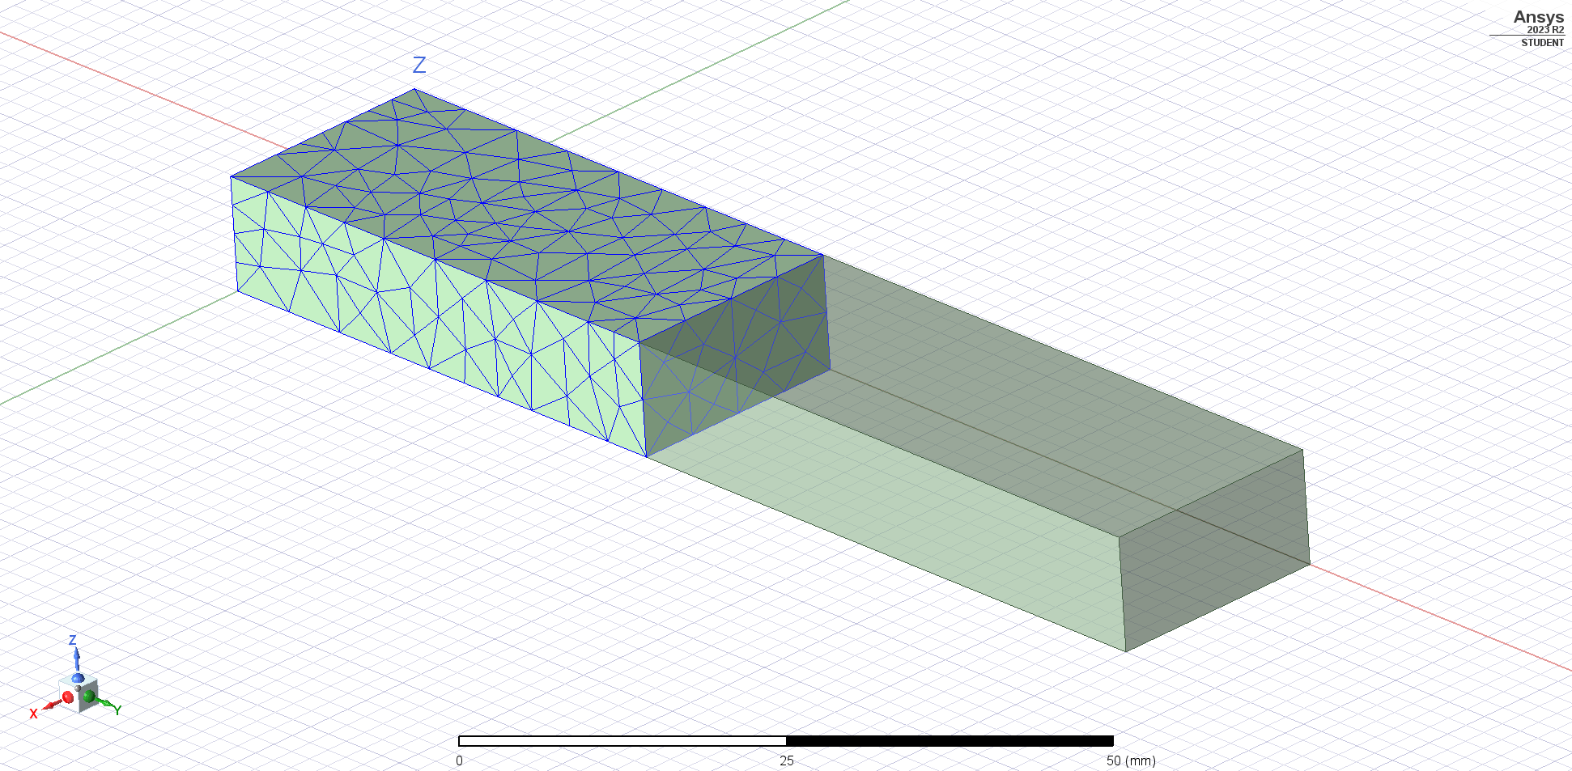

Triangulation of air volume

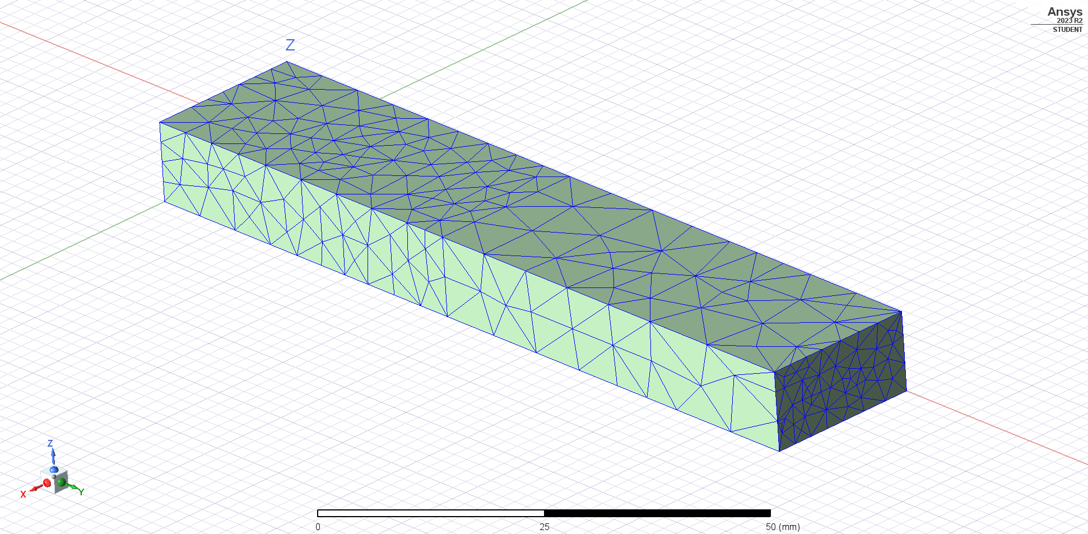

Electric field inside waveguide

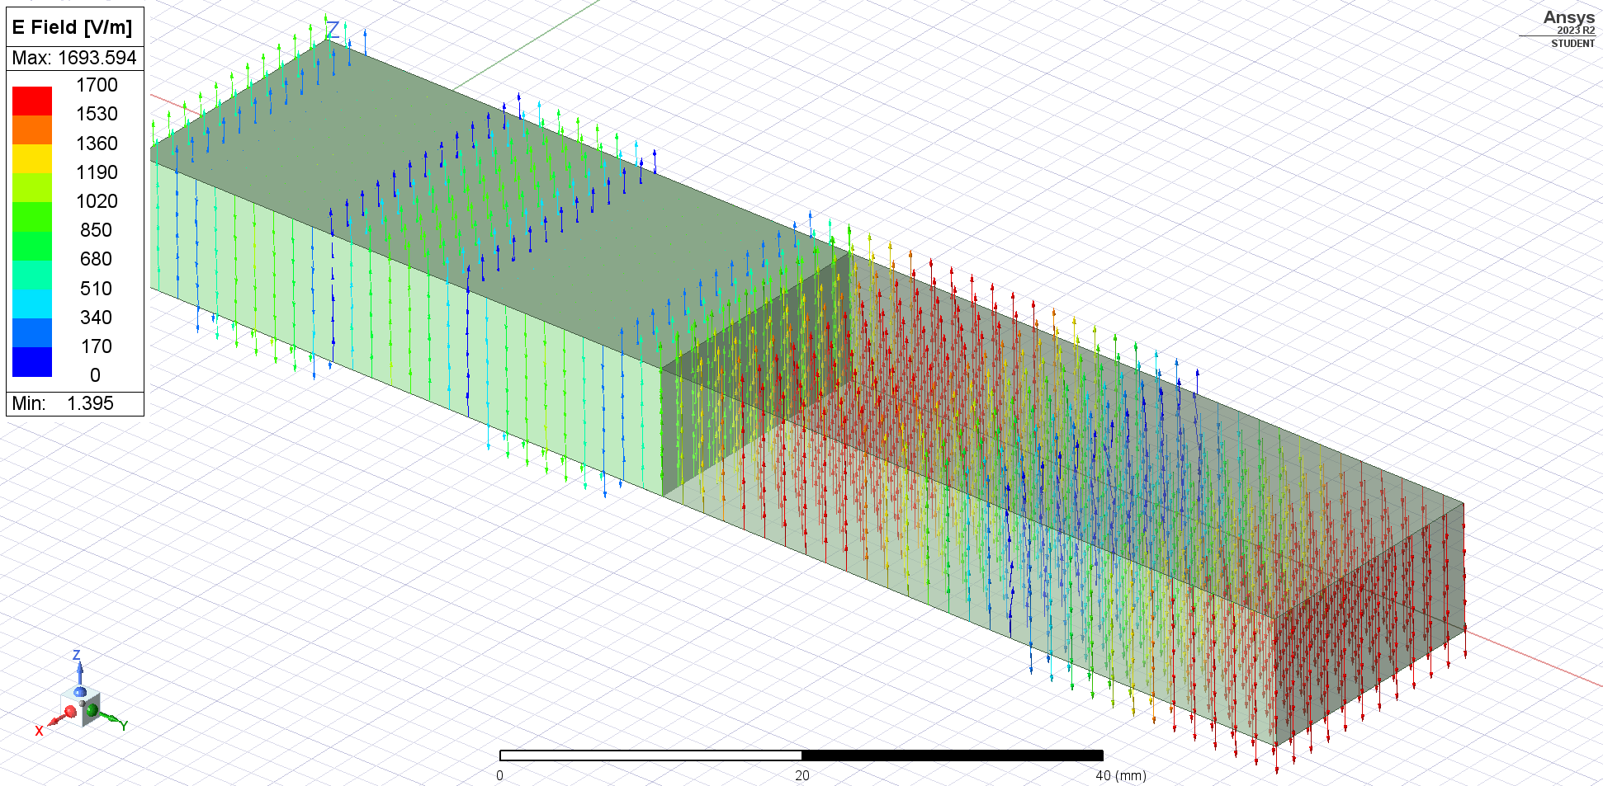

Magnetic Field inside Waveguide

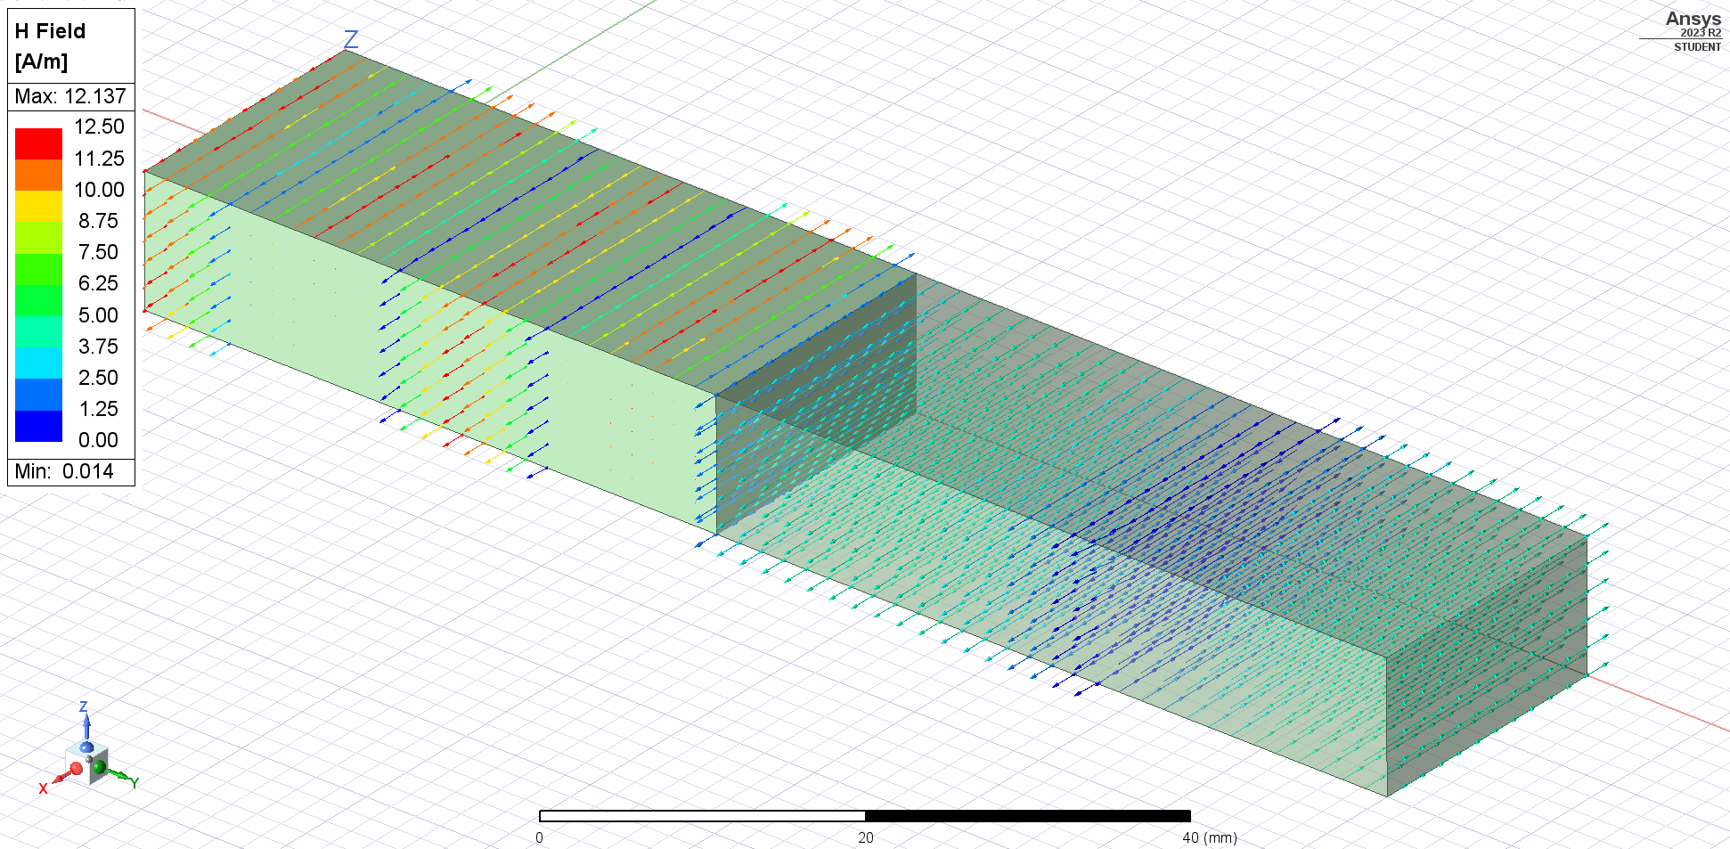

The goal of a waveguides is to transmit power, for the waveguide to be effective it must target a small reflection coefficient value. The reflection coefficient value is a ratio of how much the wave is reflected by the incoming wave.

The simulation shows that the electromagnetic field is much weaker inside custom material, this is due to reflection. The electromagnetic wave reflection is determined by the reflection coefficient, Γ, to compute this value, we must first compute the wave intrinsic impedance in each material.

Intrinsic impedance of air (same as vacuum):

$$η=\sqrt{\frac{μ_{0}}{ε_{0}}}=120π$$

Intrinsic impedance of the hypothetical material:

$$η=\sqrt{\frac{μ_{0}}{{9ε}_{0}}}=40π$$

To compute $Γ$, we use the following equation:

$$Γ=\frac{η_{2}-η_{1}}{η_{2}+η_{1}}=\frac{120π-40π}{120π+40π}=\frac{1}{2}$$

The computed reflection coefficient, Γ, exhibits a variation with changing frequency. This dynamic behavior can be attributed to the fact that both ε (permittivity) and μ (permeability) are frequency-dependent properties represented as tensors. The values we have employed to calculate Γ are applicable primarily within the realm of low frequencies.

To validate this, the simulation carried out by HFSS offers valuable insights. By plotting the S11 and S21 parameters, which describe the reflection and transmission coefficients as functions of frequency, we can obtain a comprehensive picture of how these coefficients change across different frequency ranges. This analytical approach enables us to assess the frequency-dependent characteristics of wave reflection and transmission within the waveguide accurately.

S11 Parameter Frequency Sweep Plot

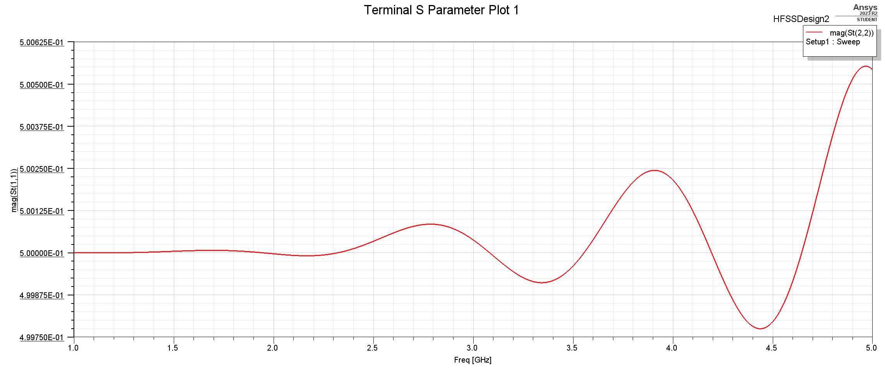

The reflection of the waveguide is primarily assessed through the S11 parameter. It's noteworthy that at lower frequencies, our initial calculations yield a high degree of accuracy. However, as the frequency increases, the reflection coefficient begins to exhibit oscillatory behavior, leading to a decrease in the precision of our calculations.

The transmission coefficient can also be verified by plotting the S21 parameter plot.

S21 Parameter Plot

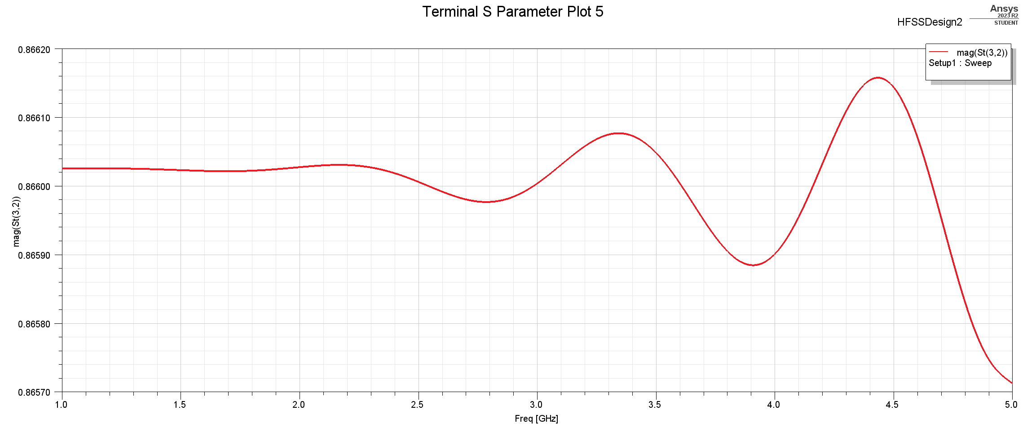

The transmission coefficient corresponds to the reflection coefficient in this context. While our calculations accurately depict the transmission coefficient at lower frequencies, it is anticipated that this accuracy diminishes as the frequency rises. This outcome is in line with expectations since the transmission coefficient is inherently linked to the reflection coefficient, with the former being equal to one plus the latter. As such, variations in the reflection coefficient naturally affect the accuracy of the transmission coefficient calculations, particularly as frequencies increase.

Indeed, if you graph the quantity |S21|^2 + |S11|^2, you are essentially calculating the sum of the total reflection power and the total transmitted power. In the context of a passive waveguide without active components, this sum should equal one. This result aligns with the fundamental principle of conservation of power, where all the incident power is accounted for either through reflection or transmission. Therefore, a graph showing |S21|^2 + |S11|^2 should consistently yield a value of one, confirming that no power is lost within the waveguide, and it's entirely accounted for in terms of reflection and transmission.

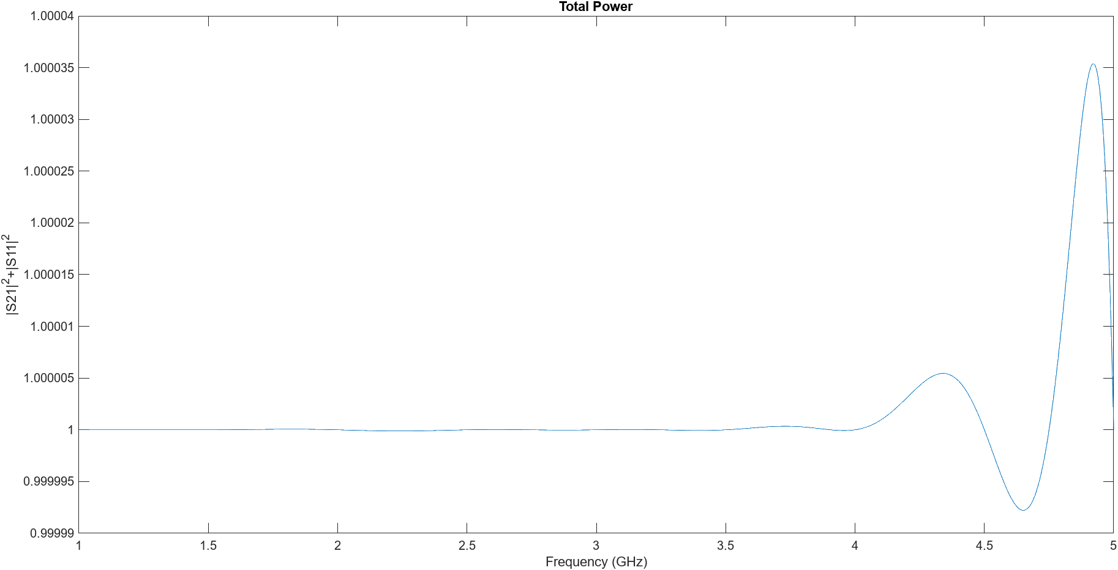

The reason for variation from 1 in this graph is due to simulation imprecision, however, the deviation is extremely small can be approximated to 1.

# **3.0 Laboratory Questions**

* 1. Animate the E field in both air and dielectric. Is it a standing wave or a propagating wave in the air and dielectric?



The E field is propagating in both the dielectric and air as shown in this animation.

* Phase step

Phase step refers to phase shift in the signal through the waveguide.

* Default port

The default port is port number 2 which is where the 4 GHz frequency enters the waveguide.

* Difference between dielectric and air regions:

The difference between air and the dielectric regions, is that the dielectric has higher epsilon value compared to the air region.

* Adaptive meshing

Adaptative meshing is technique used by HFSS to subdivide the waveguide mesh to achieve more accurate simulations. This is an iterative step in which HFSS will incrementally increase the tetrahedral count in each iteration. This can be seen in the following image. The first image shows the mesh after only 1 iterations vs the second image which shows the mesh after the 5th iteration.

Mesh after 1st iteration

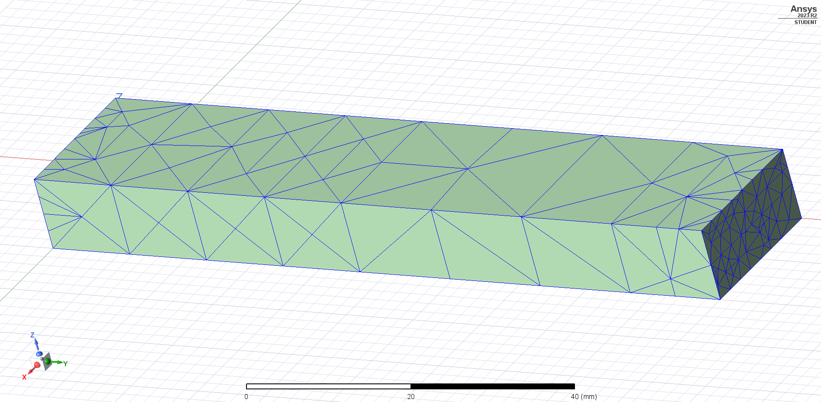

Mesh after 5th iteration

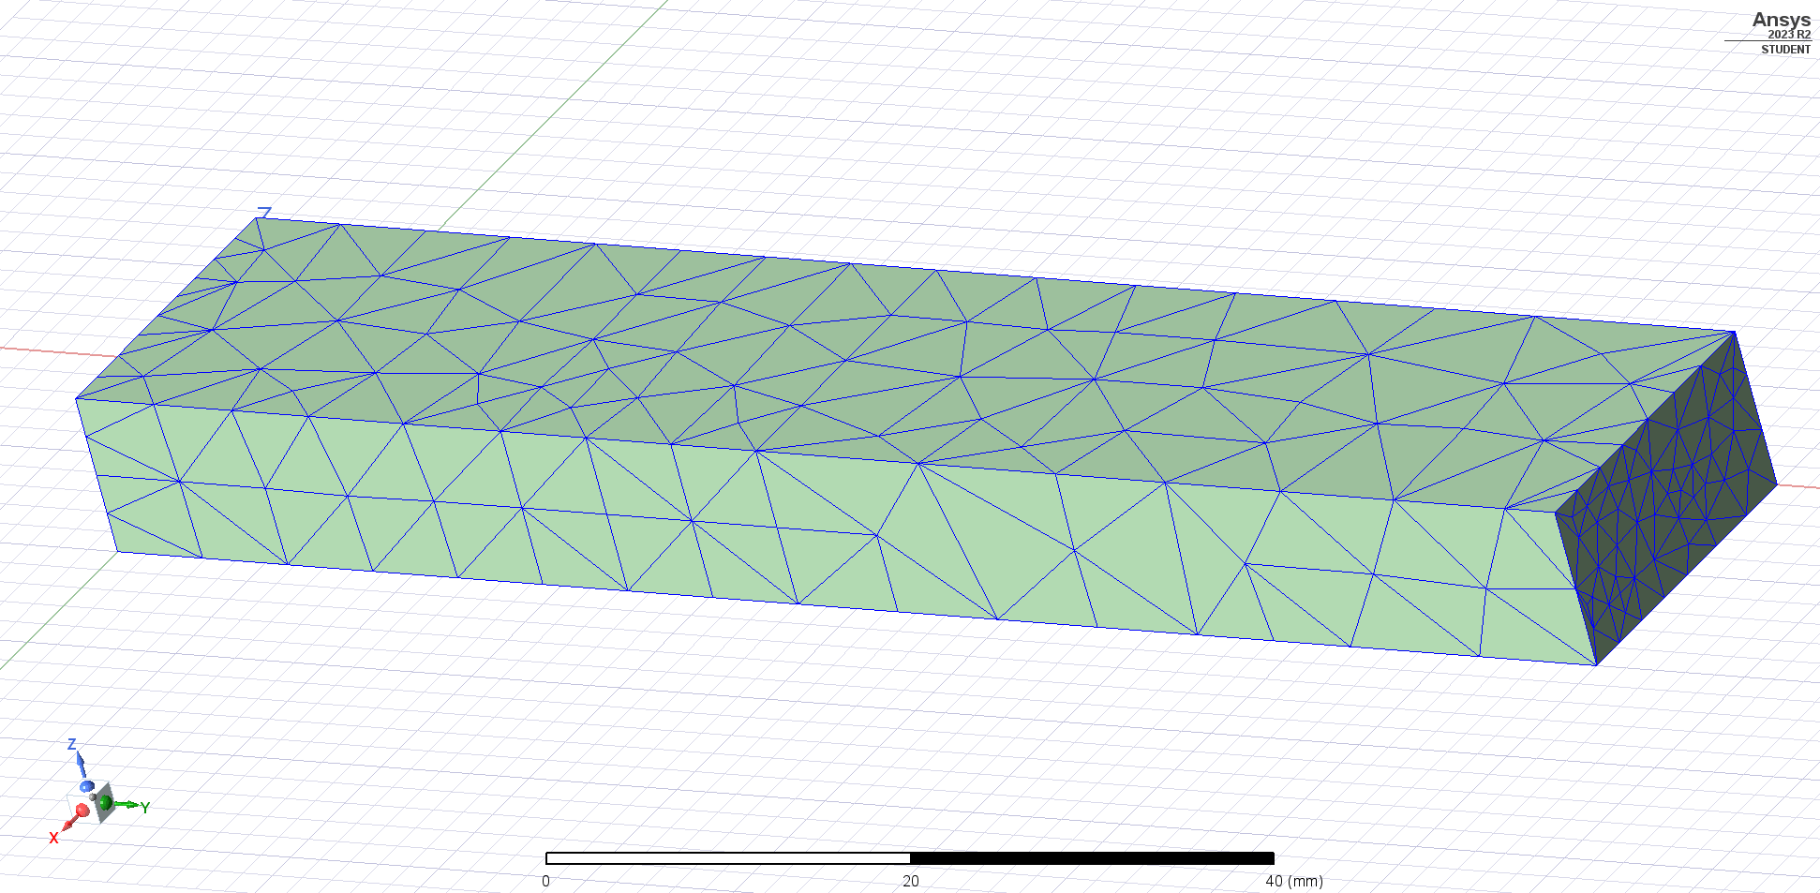

* Plot the E and H field in the dielectric. Are they in phase with each other? Why?

The E and H field are in phase with each other inside the dielectric this is because epsilon value is not a complex value and therefore the H field will not experience any phase shifts.

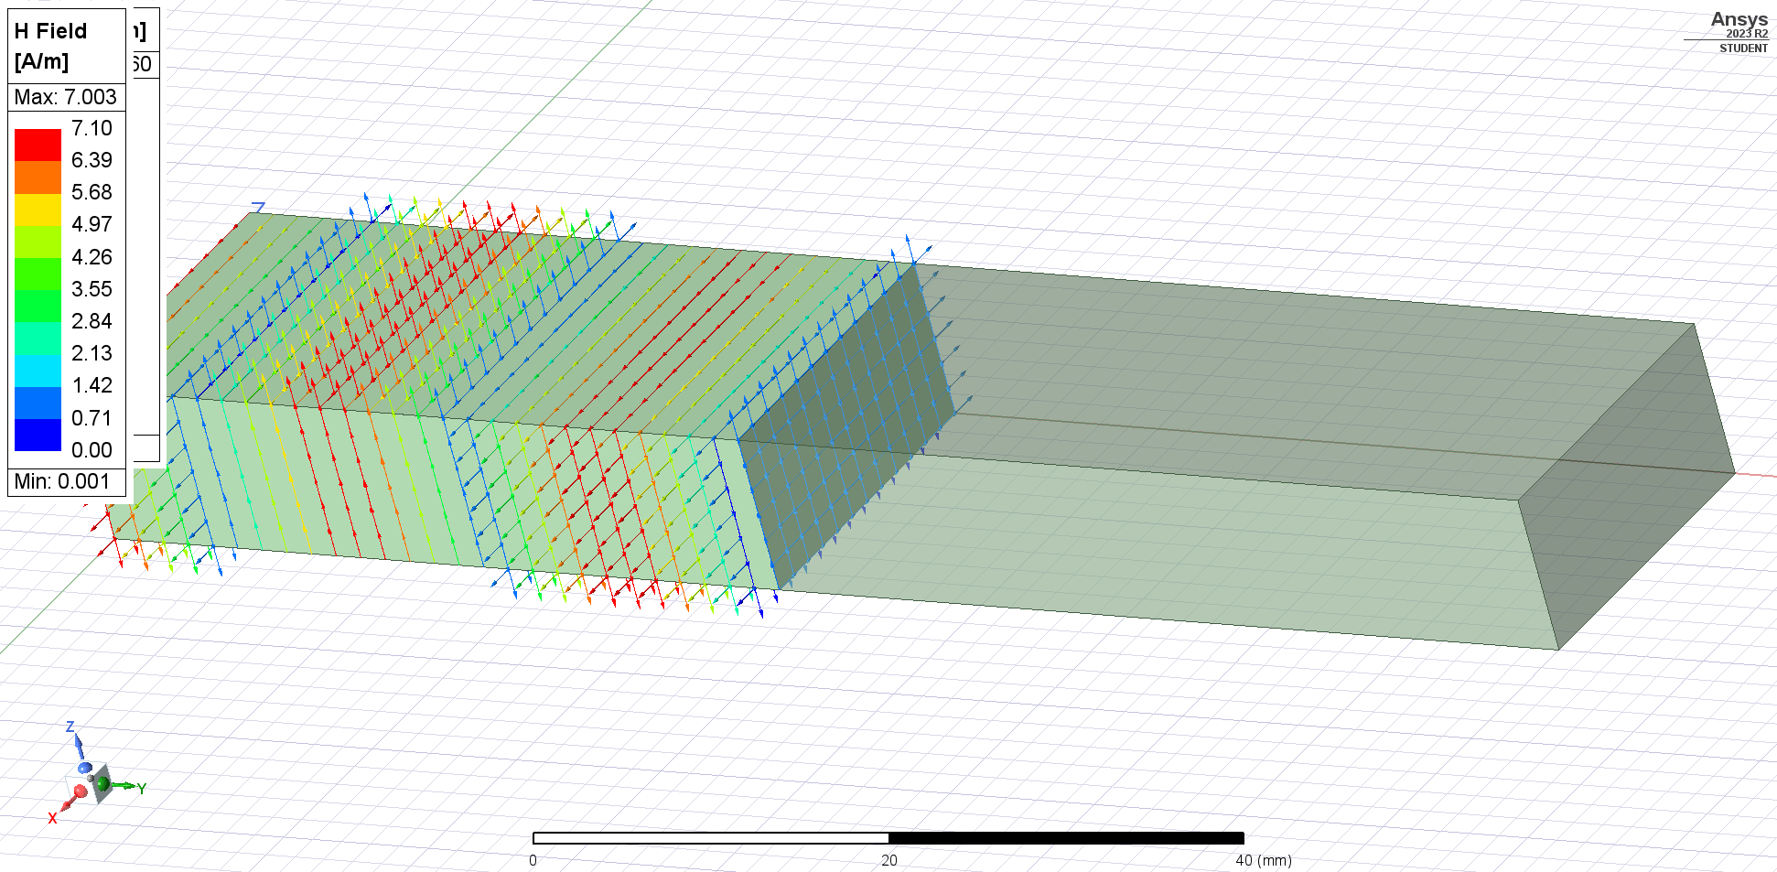

# **4.0 Learned Objectives**

* Reflection and Transmission Coefficient
* Waveguides
* S Parameters
* HFSS Simulation
* Frequency dependent reflection coefficient

# **5.0 Conclusion**

This virtual lab on plane waves and waveguide analysis offered a practical exploration of fundamental microwave engineering principles. Through simulations and analyses, we gained insights into the behavior of electromagnetic waves within waveguides, especially regarding reflection and transmission. The understanding and skills acquired in this lab contribute to a solid foundation in microwave engineering.